**Entity-Specific Implementation Plans for Achieving Gender Parity**

**2025-2026**

The [Secretary-General’s System-wide Strategy on Gender Parity](https://www.un.org/gender/content/strategy) recommends all **UN system entities to align or develop specific gender strategies and implementation plans**, which include specific targets, measures, and resources, to reach the goals and reflect the recommendations of the Strategy. With only four years left to reach the Secretary-General’s goal of 50/50 balance across the UN System, it is more important than ever to take holistic stock of progress made and create a comprehensive action plan to make parity a reality at all levels of staff and all locations. While historic progress has been made at headquarters locations, the share of women in field and mission settings has continued to lag. The Beijing+30 framework provides us an important opportunity to renew commitments and intensify our efforts.

This template sets out a simple framework for addressing the different facets of the System-wide Strategy. This tool is meant to serve as a starting point for designing and implementing a plan to achieve gender parity by 2028. We have also created a guidance note to help you formulate your implementation plans. There is also room for additional notes or information within each section, and please feel free to include additional documentation with this template.

|  |  |
| --- | --- |
| 1. **Setting Targets & Monitoring Progress** 2. **Leadership & Accountability** 3. **Recruitment, Retention, Progression, and Talent Management** | 1. **Creating an Enabling Environment** 2. **Mission & Field Settings (if applicable)** 3. **National Professional Officers and General Services Staff (if applicable)** |

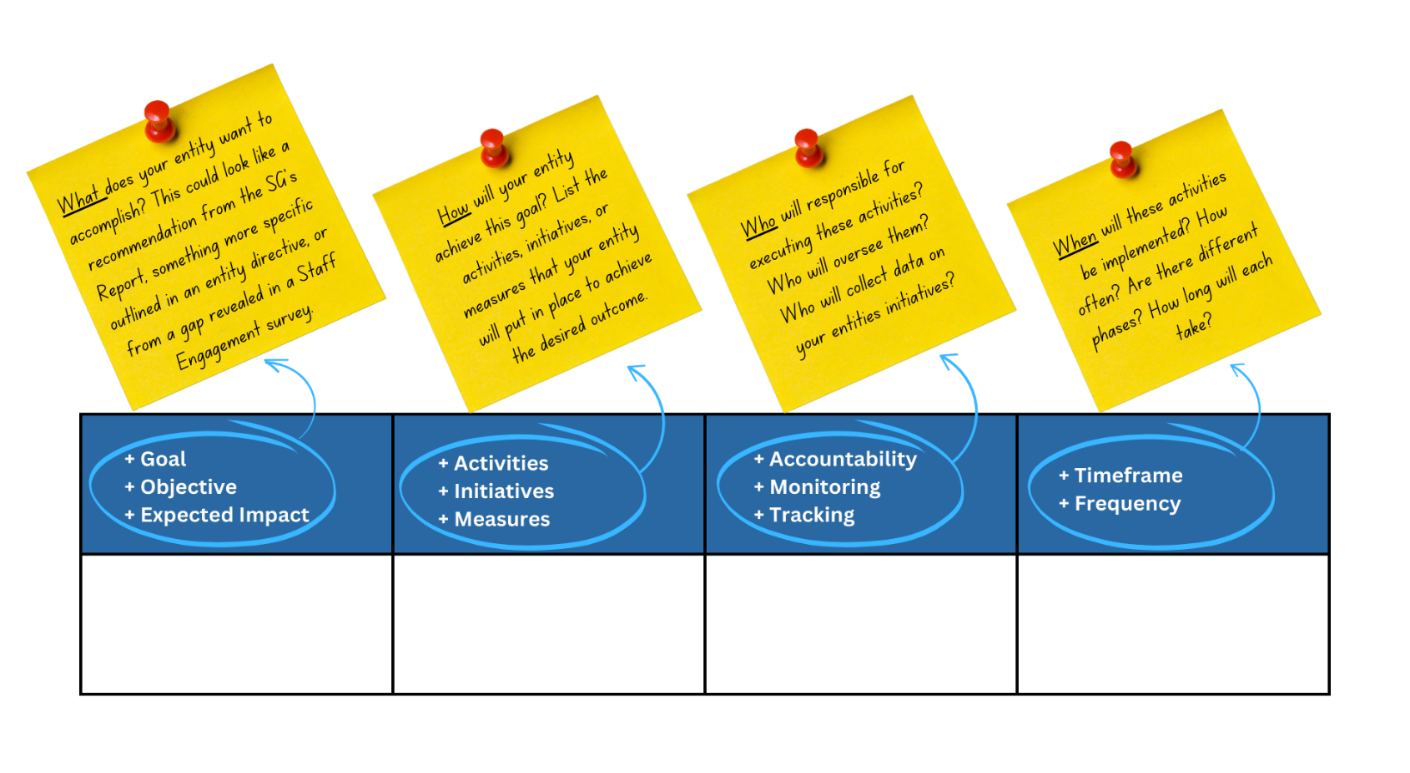

|  |  |
| --- | --- |
| **Entity Name** |  |
| **Gender Focal Point** |  |
| **Email** |  |
| **Telephone** |  |

|  |  |  |  |
| --- | --- | --- | --- |
| 1. **Setting Targets & Monitoring Progress** | | | |
| * Goal * Objective * Expected Impact | * Activities * Initiatives * Measures | * Accountability * Monitoring * Tracking | * Timeframe * Frequency |
| *For example: Ensure availability of data and statistics to monitor progress and achieve targets.* | *The Human Resources Department will monitor progress against targets and provide a progress report to the concerned Department, Field Office and the Executive Office once every 3 months.* | *Human Resource Department* | *Every 3 months* |
|  |  |  |  |
|  |  |  |  |
|  |  |  |  |
| **Additional notes or information:** | | | |

|  |  |  |  |
| --- | --- | --- | --- |
| 1. **Leadership & Accountability** | | | |
| * Goal * Objective * Expected Impact | * Activities * Initiatives * Measures | * Accountability * Monitoring * Tracking | * Timeframe * Frequency |
| *For example: Increased accountability and transparency on gender equality, diversity and inclusion* | *Senior leaders participate in a review meeting of gender parity targets and initiatives to improve the work environment* | *Senior Leadership* | *Quarterly* |
|  |  |  |  |
|  |  |  |  |
|  |  |  |  |
|  |  |  |  |
|  |  |  |  |
| **Additional notes or information:** | | | |

|  |  |  |  |
| --- | --- | --- | --- |
| 1. **Recruitment, Retention, Progression and Talent Management** | | | |
| * Goal * Objective * Expected Impact | * Activities * Initiatives * Measures | * Accountability * Monitoring * Tracking | * Timeframe * Frequency |
| *For example: Address unconscious biases in recruitment and promote fairness and diversity in recruitment* | *Create diversity Toolkit, guidance notes and an interview package to supplement the existing recruitment guide.*  *These efforts aimed at providing comprehensive guidance to hiring managers on available tools and processes to minimize bias, and ensure diversity and inclusion throughout the recruitment process.* | *Hiring Managers with Gender Focal Points* | *2025-2027* |
|  |  |  |  |
|  |  |  |  |
|  |  |  |  |
|  |  |  |  |
|  |  |  |  |
| **Additional notes or information:** | | | |

|  |  |  |  |
| --- | --- | --- | --- |
| 1. **Creating an Enabling Environment** | | | |
| * Goal * Objective * Expected Impact | * Activities * Initiatives * Measures | * Accountability * Monitoring * Tracking | * Timeframe * Frequency |
| *For example: Form peer support groups of women, including women from different professional areas and different regional offices; provide a platform to highlight specific needs of female personnel; share issues arising from these meetings with Gender Focal Points to further improve the working environment.* | *Set up a core group of senior staff champions, men and women, from different regions, to brainstorm on how to address some of the implicit and explicit ways of exclusion, harassment and discrimination that can make the workplace challenging for women* | *Senior Leadership*  *Gender Focal Points*  *DEI*  *Human Resources* | *2025*  *Quarterly* |
|  |  |  |  |
|  |  |  |  |
|  |  |  |  |
| **Personal & Professional Life Integration** | | | |
|  |  |  |  |
|  |  |  |  |
|  |  |  |  |
|  |  |  |  |
| **Standards of Conduct** | | | |
|  |  |  |  |
|  |  |  |  |
|  |  |  |  |
|  |  |  |  |
| **Diversity & Inclusion** | | | |
|  |  |  |  |
|  |  |  |  |
|  |  |  |  |
|  |  |  |  |
| **Gender Focal Point Network** | | | |
|  |  |  |  |
|  |  |  |  |
|  |  |  |  |
|  |  |  |  |
| **Additional notes or information:** | | | |

|  |  |  |  |
| --- | --- | --- | --- |
| 1. **Mission & Field Settings** | | | |
| * Goal * Objective * Expected Impact | * Activities * Initiatives * Measures | * Accountability * Monitoring * Tracking | * Timeframe * Frequency |
| *For example: Improve working and living conditions to provide a safe and supportive environment for all.* | *Non-family duty stations shall comply with a series of workplace and accommodation minimum standards, including "camp" environments. These measures shall include improvements such as internal toilets and kitchenettes in containerized accommodation, safe recreational spaces, and design of camps so that police and military elements are cantoned separately from civilian staff. The Mission shall meet these standards across its installations progressively.* | *Leadership, Engineering Logistics* | *Progressively* |
|  |  |  |  |
|  |  |  |  |
|  |  |  |  |
|  |  |  |  |
|  |  |  |  |
| **Additional notes or information:** | | | |

|  |  |  |  |
| --- | --- | --- | --- |
| 1. **Enhancing Gender Parity Among**   **National Professional Officers and General Services Staff** | | | |
| * Goal * Objective * Expected Impact | * Activities * Initiatives * Measures | * Accountability * Monitoring * Tracking | * Timeframe * Frequency |
| *For example: Strengthen recruitment of women in mission contexts* | *Launch women’s career coaching program targeting national professional female staff to participate in a series of personal career coaching development events, combined with a series of group mentoring workshops which aim at supporting participants in their career development.* | *Senior Staff*  *Hiring Managers*  *Gender Focal Points*  *HQ* | *2026* |
| **National Professional Officers** | | | |
|  |  |  |  |
|  |  |  |  |
|  |  |  |  |
| **General Service Staff** | | | |
|  |  |  |  |
|  |  |  |  |
|  |  |  |  |
| **Additional notes or information:** | | | |